Object Relational Mapping (ORM) is a technique or design pattern, which maps an object model with the relational model. It has the following features:
- It resolves object-relational impedance mismatch by mapping
  - Java classes to tables in the database
  - Instance variables to columns of a table
  - Objects to rows in the table
- It helps the developer to get rid of SQL queries so that they can concentrate on the business logic which leads to faster development of the application.
- It is database independent. All database vendors provide support for ORM. Hence, the application becomes portable without worrying about the underlying database.
To use ORM in Java applications, Java Persistence API (JPA) specification is used. It has many implementations such as Hibernate, OpenJPA, TopLink, EclipseLink, etc. In this course we will use Hibernate implementation.
The Java Persistence API (JPA) is a specification that defines standard for using object relational mapping (ORM) in Java applications for interacting with relational database. It provides:
- API to map classes with tables
- API for performing CRUD operations
- Java Persistence Query Language (JPQL), a querying language for fetching data from database
- Criteria API which uses object graph to fetch data from database
JPA is an interface and Hibernate implements its specification. Hibernate is one of the most popular ORM frameworks.
The classes which are mapped to a table and whose instance represents a row in table are entity classes. JPA provides annotations to create entity classes which are present in the javax.persistence package. Some of these annotations are as follows:
- @Entity: It specifies that the Java class is an entity class.
  - @Entity
  - public class Customer {
  - //rest of the code
  - }
- @Id: Every object of entity class must have an attribute which uniquely identifies it. This is called as primary key attribute or identifier. Usually, it is the attribute mapped to the primary key column of table. It is specified using @Id annotation.
  - @Entity
  - public class Customer {
  - @Id
  - private Integer customerId;
  - //rest of the code
  - }
- @Table: It specifies the table with which entity class is mapped. By default, entity class is mapped with a table which has same name as the class name. If entity class has to be mapped with a table whose name is different from class name then, this annotation is used. For example, if CustomerDetails class has to be mapped with customer table then the annotation needs to be used as follows:
  - @Entity
  - @Table(name="customer")
  - public class CustomerDetails {
  - @Id
  - private Integer customerId;
  - //rest of the code
  - }
- @Column: It specifies the name of column in table with which attribute in entity class is mapped. By default, column name is mapped with a column which has same name as the attribute name. If attribute name is different from column name, then this annotation is used. For example, if customerId is to be mapped to customer_id column, then the annotation needs to be used as follows:
  - @Entity
  - @Table(name="customer")
  - public class Customer {
  - @Id
  - @Column(name="customer_id")
  - private Integer customerId;
  - //rest of the code
  - }
- @Transient: It specifies the attributes which are not stored in table.
Consider the CUSTOMER table given below and its corresponding Customer entity class
- @Entity
- public class Customer {
- @Id
- @Column(name="customer_id")
- private Integer customerId;
- @Column(name="email_id")
- private String emailId;
- private String name;
- @Column(name="date_of_birth")
- private LocalDate dateOfBirth;
- //getter and setters
- }
In the above code, the name of attributes customerId, emailId and dateOfBirth are different from the column names. So, @Column annotation is used.
Sometimes, entity class has a reference of enum and if you want to persist it, you can use @Enumerated annotation. For example, consider the following Java class which as a reference to CustomerType enum and you have to map it to CUSTOMER table in the database:
- public enum CustomerType{
- SILVER,GOLD,PLATINUM;
- }
- @Entity
- public class Customer {
- @Id
- @Column(name="customer_id")
- private Integer customerId;
- @Column(name="email_id")
- private String emailId;
- private String name;
- @Column(name="date_of_birth")
- private LocalDate dateOfBirth;
- @Enumerated(EnumType.STRING)
- private CustomerType customerType;
- //getters and setters
- }
In the above code, CustomerType is annotated with @Enumerated annotation. The EnumType property is used to specify how the enum should be persisted in the database.
The possible values of EnumType property are as follows:
- @Enumerated(EnumType.STRING) specifies that the enum will be written and read from the corresponding database column as a String. So, customerType set to SILVER will be persisted as SILVER.
- @Enumerated(EnumType.ORDINAL) specifies that the enum will be persisted as an integer value. So, customerType set to SILVER will be persisted as 0 and customerType set to GOLD will be persisted as 1. The default is EnumType.ORDINAL.

Need of JPA
As we have seen so far, JPA is a specification. It provides common prototype and functionality to ORM tools. By implementing the same specification, all ORM tools (like Hibernate, TopLink, iBatis) follows the common standards. In the future, if we want to switch our application from one ORM tool to another, we can do it easily.

JPA vs. Hibernate
JPA | Hibernate
Java Persistence API (JPA) defines the management of relational data in the Java applications. | Hibernate is an Object-Relational Mapping (ORM) tool which is used to save the state of Java object into the database.
It is just a specification. Various ORM tools implement it for data persistence. | It is one of the most frequently used JPA implementation.
It is defined in javax.persistence package. | It is defined in org.hibernate package.
The EntityManagerFactory interface is used to interact with the entity manager factory for the persistence unit. Thus, it provides an entity manager. | It uses SessionFactory interface to create Session instances.
It uses EntityManager interface to create, read, and delete operations for instances of mapped entity classes. This interface interacts with the persistence context. | It uses Session interface to create, read, and delete operations for instances of mapped entity classes. It behaves as a runtime interface between a Java application and Hibernate.
It uses Java Persistence Query Language (JPQL) as an object-oriented query language to perform database operations. | It uses Hibernate Query Language (HQL) as an object-oriented query language to perform database operations.
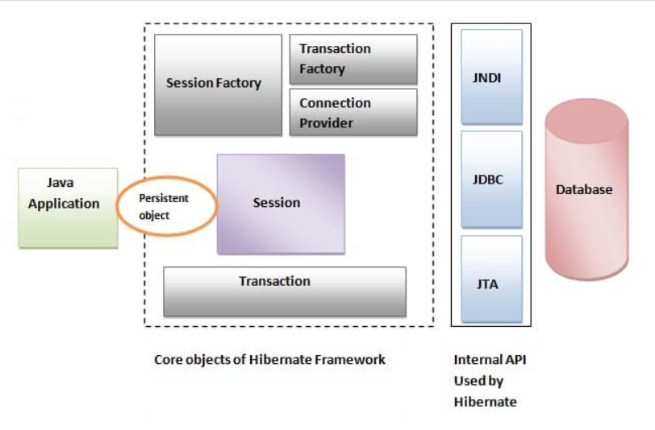
Why overriding equals() and hashCode() methods in entity class is considered to be a good practice?
This is because each instance of an entity class represents a row in database and in real time, you may have many objects of this class. So, you need to differentiate one object from the other. JPA ensures that there is a unique instance for each row of the database but if you want to store the objects in a Set, then you need to override equals() and hashCode() methods.
Every entity object has a state in relation to both persistence context and the database. Every entity object has different states depending on its relationship with persistence context. This defines the life cycle of an entity object. The different states of an entity object during its life cycle are as follows:
- New/Transient State: A newly created entity object which has no persistence context associated with it and having no row associated with it in a table in database is said to be in new or transient state.
- Managed/Persistent State: An entity object which has a persistence context and an identifier value associated with it is said to be in managed or persistent state. It may or may not have a row associated with it in a table.
- Removed State: An entity object which has a row associated with it in a table and associated with a persistence context, but marked for deletion from the database is said to be in removed state.
- Detached State: An entity object which is no longer associated with a persistence context with which it was previously associated with it is said to be in detached state. This usually happens when session gets closed or the object was evicted from the persistence context.
You will now have a look at some of the important methods of the EntityManager interface.
- When the object of an entity class is created it will be in a new state.
- When persist() method is called the entity will move from new to managed state.
- When the transaction is committed a new row is inserted in the table and the entity continues to be in a managed state.
During update operation entity will go through the following states:
- When an entity object is retrieved using find() method the entity object is in managed state.
- After updating the entity remains in the managed state.
- When the transaction is committed the changes will be reflected in the table and the entity continues to be in a managed state.

- void persist(Object entity) - It makes a new entity object managed. When transaction is committed, a new row will be inserted in the database.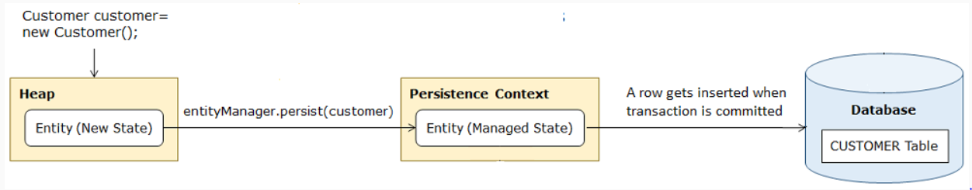
- find(Class entityClass, Object primaryKey) - It searches the database table based on the primaryKey and returns the row as an object of entity class. It returns null if no row is present in the database. It returns the entity object in the managed state.
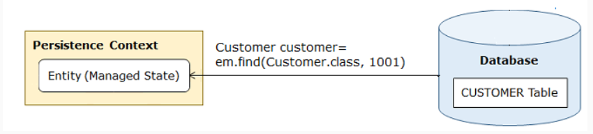
- void remove(Object entity) - It changes the state of entity object from managed to removed and object gets deleted from the database when transaction is committed.
During delete operation entity object will go through the following states:
- When an entity object is retrieved using find() method the entity object is in a managed state.
- When remove() method is called the entity object will move from managed to removed state. Any changes made to the object in the removed state are not saved to the database.
- When the transaction is committed the corresponding row will get deleted from the table and the entity moves to a new state.

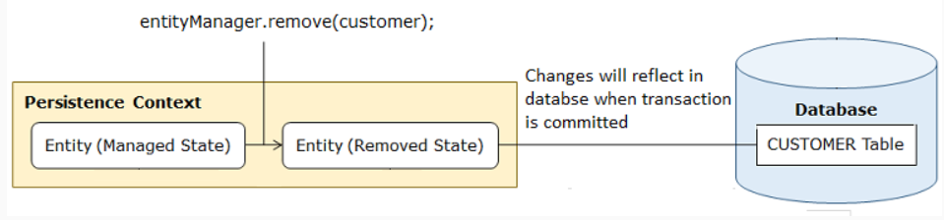
- void detach(Object entity) - It detaches the given entity from the persistence context associated with it and changes its state to detached.
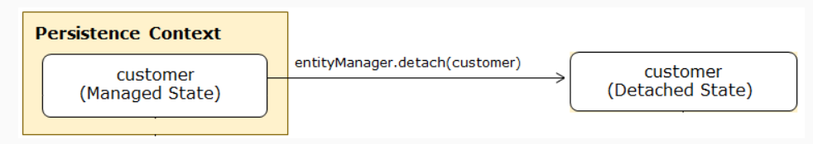
So far, we have learnt that an object is in the managed state when it is associated with an entity manager. An object which was previously in the managed state but now not associated with an entity manager is said to be in a detached state. Any change in the state of the detached object will not be reflected in the database but detached objects can be re-attached with the session. An object in the managed state can be moved to a detached state using the following methods:
- void detach(Object object): Removes the object from the entity manager.
- boolean close(): All the objects associated with an entity manager will be removed after calling this method and it also closes the entity manager by releasing database connection.
- void clear(): All the objects associated with an entity manager will be removed from the session after calling this method.
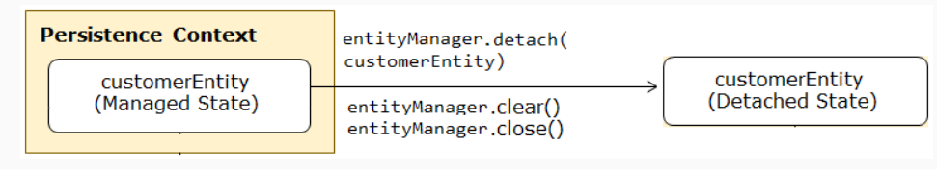
Transaction management is important while writing persistence layer code for maintaining database integrity and consistency. If transaction management is not done properly, database may get corrupted and left in an inconsistent state. This can be done in following two ways:
- Programmatic transaction management : In programmatic transaction management, the following code to manage transactions is written in each method which needs transaction:
  - Transaction transaction = entityManager.getTransaction()
  - try{
  - transaction.begin();
  - // business logic
  - transaction.commit();
  - }
  - catch(Exception exception){
  - transaction.rollback();
  - throw exception;
  - }
As this code is repeated in each of the methods which need transaction, this way of transaction management is not preferred.
- Declarative transaction management: In declarative transaction management code to manage transactions is separated from your business logic. This makes transaction management easier. So, this way is usually preferred for transaction management. This is done using @Transactional annotation which you have already seen in the previous demo.
You can annotate a class or its transactional methods with @Transactional annotation. When it is used at class level, then all its public methods become transactional. Otherwise, only those methods of the class which are annotated with this annotation becomes transactional. If this annotation is placed at class level as well as method level then method level definition overrides the class definition.
The attributes of @Transactional annotation has default values. You can change these values according to the requirement of your application. The default values of its different attributes are as follows:
- isolation = DEFAULT
- propagation = REQUIRED
- timeout = TIMEOUT_DEFAULT
- readOnly =false
- rollbackFor = RuntimeException or its subclasses
- noRollbackFor = Exception or its subclasses
You can use this annotation with repository or service classes but it is a good practice to use it with service classes. This is because service class may call methods of different repository classes to perform database operations and if any of these methods throw exception, you may end up with inconsistent database state. So, annotating service class with this annotation prevents these types of situations.
However, in a Spring-based application, classes implementing Service Layer are specifically assigned for interaction with Persistence Layer. Hence, it is a best practice to annotate only Service Layer classes and/or it's methods with @Transactional and interact with the Persistence Layer.
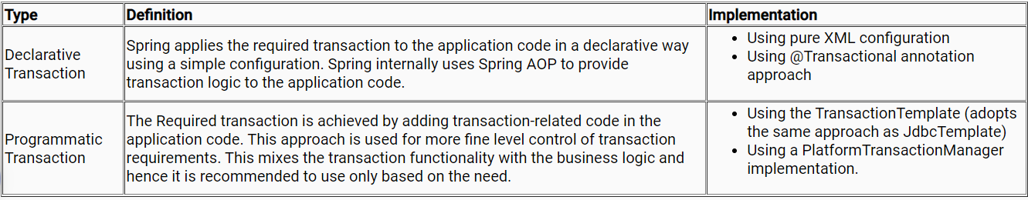
This annotation will be identified automatically by Spring Boot if we have already included the spring-boot-starter-data-jpa jar.
Should the developer use @Transactional annotation before every method?
No, @Transactional annotation can be placed at the class level which makes all its methods execute in a transaction scope. For e.g. insertCustomer() and updateCustomerDetails() methods executes in transaction scope.

Now that you know, how to use @Query annotation for query operations.
Can @Query annotation be used for performing modification operations?
Yes, it can execute modifying queries such as update, delete or insert operations using @Query annotation along with @Transactional and @Modifying annotation at query method.
Example: Interface with a method to update the name of a customer based on the customer's address.
- public interface CustomerRepository extends JpaRepository<Customer, Long> {
- @Transactional
- @Modifying(clearAutomatically = true)
- @Query("update Customer c set c.name = ?1 where c.address = ?2")
- void update(String name, String address);
- }

Let us now understand in detail, why there is a need for the following:
@Modifying: This annotation will trigger @Query annotation to be used for an update operation instead of a query operation.
@Modifying(clearAutomaticall= true): After executing modifying query, EntityManager might contain unrequired entities. It is a good practice to clear the EntityManager cache automatically by setting @Modifying annotation’s clearAutomatically attribute to true.
@Transactional: Spring Data provided CRUD methods on repository instances that support transactional by default with read operation and by setting readOnly flag to true. Here, @Query is used for an update operation, and hence we need to override default readOnly behavior to read/write by explicitly annotating a method with @Transactional.
@Modifying: This annotation triggers the query annotated to a particular method as an updating query instead of a selecting query. As the EntityManager might contain outdated entities after the execution of the modifying query, we should clear it. This effectively drops all non-flushed changes still pending in the EntityManager. If we don't wish the EnetiyManager to be cleared automatically we can set @Modifying annotation's clearAutomatically attribute to false.
Fortunately, starting from Spring Boot 2.0.4.RELEASE, Spring Data added flushAutomatically flag to auto flush any managed entities on the persistence context before executing the modifying query.
Thus, the safest way to use Modifying is:
- @Modifying(clearAutomatically=true, flushAutomatically=true)
Now let's take a small scenario where we don't use these two attributes with @Modifying annotation:
Assume a Customer table with two columns name and active, exists in the database with only one row as Tom, true.
Repository:
- public interface CustomerRepository extends JPARepository<Customer, Intger> {
- @Modifying
- @Query("delete Customer c where c.active=0")
- public void deleteInActiveCustomers();

- }
In the above repository, @Modifying annotation is used without clearAutomatically and flushAutomatically attributes. So, let's visualize what happens when the Service call happens.
Visualization -1: If flushAutomatically attribute is not used in the Repository:
- public class CustomerServiceImpl implements CustomerService {
- Customer customerTom = customerRepository.findById(1); // Stored in the First Level Cache
- customerTom.setActive(false);
- customerRepository.save(customerTom);

- customerRepository.deleteInActiveUsers();// By all means it won't delete the customerTom

- /*customerTom still exist since customerTom with 'active' attribute being set to false was not flushed into the database when @Modifying kicks in*/
- }

Visualization -2: If clearAutomatically attribute is not used in the Repository:
- public class CustomerServiceImpl implements CustomerService {
- Customer customerTom = customerRepository.findById(1); // Stored in the First Level Cache
- customerRepository.deleteInActiveCustomers(); // We think that customerTom is deleted now
- System.out.println(customerRepository.findById(1).isPresent()) // Will return TRUE
- System.out.println(customerRepository.count()) // Will return 1

- // TOM still exist in this transaction persistence context
- // TOM's object was not cleared upon @Modifying query execution
- // TOM's object will still be fetched from First Level Cache
- /* clearAutomatically attribute takes care of doing the clear part on the objects being modified for current transaction persistence context*/
- }
- @Transactional annotation supports the following attributes:
- Transaction isolation: The degree of isolation of this transaction with other transactions.
- Transaction propagation: Defines the scope of the transaction.
- Read-only status: A read-only transaction will not modify any data. Read-only transactions can be useful for optimization in some cases.
- Transaction timeout: How long a transaction can run before timing out.
- The default @Transactional settings are as follows:
@Transactional Attribute | Default values
Propagation | PROPOGATION_REQUIRED
Isolation level | ISOLATION_DEFAULT
Transaction Type | Read/Write
Timeout | Based on the underlying database settings
Rollback condition | Rollback on runtime exception and no rollback on checked exception

@PersistenceContext should be preferred over @Autowired for injecting EntityManager
- @Repository(value = "customerRepository")
- public class CustomerRepositoryImpl implements CustomerRepository {

- @PersistenceContext
- private EntityManager entityManager;

- // rest of the code
- }

Why should @PersistenceContext should be used?
When multiple clients call the application, each call creates a unique thread.
Persistence Context is specifically designed so as to create unique EntityManager for every thread whereas Autowired creates the same Entity Manager for all the threads. This can become a design flaw as multiple clients may access the same entity.
Thus, as a best practice, always use @PersistenceContext for injecting the EntityManager.

To create and execute JPQL queries, JPA provides Query interface. An object of Query interface is created through EntityManager interface using createQuery method as follows:
- Query query = entityManager.createQuery("SELECT c FROM Customer c");
where SELECT c from CustomerEntity c is a JPQL query.
This interface provides following methods to execute a query:
- List getResultList() : This method executes select queries and returns a List of results. It throws IllegalStateException if called for update and delete queries.
- Integer executeUpdate() : This method executes update and delete queries. It returns the number of rows updated or deleted. It throws IllegalStateException if called for select queries.
- Object getSingleResult() : This method executes select query which returns a single result. If no result available it throws NoResultException. It throws NonUniqueResultException if query returns more than one results and IllegalStateException if called for update and delete queries.
- Query query = entityManager.createQuery("SELECT c FROM Customer c");
- List<Customer> customers = query.getResultList();
If query returns a java.util.Collection, which allows duplicates, you must specify the DISTINCT keyword to eliminate duplicates.
To implement this user story, you need to filter entities based on customerId. This can be done using the WHERE clause. The following JPQL query fetches details of a customer whose customerId is 1002:
- SELECT c FROM Customer c WHERE c.customerId = 1002;
In the above query, customerId is hardcoded. But you can also define input parameters for a query that can be bound with values. There are following two ways using which you can define these parameters:
1. Named Parameters
The input parameters which are prefixed with a colon (:) are called as named parameters. For example, in following JPQL query: customerId is a named parameter:
- SELECT c FROM Customer c WHERE c.customerId = :customerId;
Before executing above query values for input parameters must be set. This can be done using setParameter() method of Query interface as follows:
- List<Customer> getCustomerDetails(Integer customerId){
- Query query = entityManager.createQuery("SELECT c FROM Customer c WHERE c.customerId = :customerId";
- query.setParmeter("customerId",customerId);
- List results = query.getResultList(;
- //rest of the code
- }
In the above code, the setParameter() method accepts the name of the named parameter as first argument and the value which has to be assigned to the named parameter as the second argument.
2. Positional Parameters
The input parameters which are prefixed with a question mark (?) followed the numeric position of the parameter in the query starting from 1 are called as positional parameters. For example, in following JPQL query customerId is mentioned as a positional parameter:
- select c FROM Customer c WHERE c.customerId = ?1;
The values for positional parameters can be set by calling the setParameter() method as follows:
- List<Customer> getCustomerDetails(Integer customerId){
- Query query = entityManager.createQuery("SELECT c FROM Customer c WHERE c.customerId = ?1";
- query.setParmeter(1,customerId);
- List results = query.getResultList();
- //rest of the code
- }
In the above code, the setParameter() method accepts the numeric position of the parameter in the query as the first argument and value which has to be set to a parameter as the second argument.
2. SIZE
It restricts the query result on the basis of number of associated entities. The following JPQL query returns those customers which are having more than two loans:
- SELECT c FROM Customer c WHERE SIZE(c.loans) > 2
JPQL provides string functions. These functions can be used WHERE and SELECT clause of query. The following table shows some of the string functions:
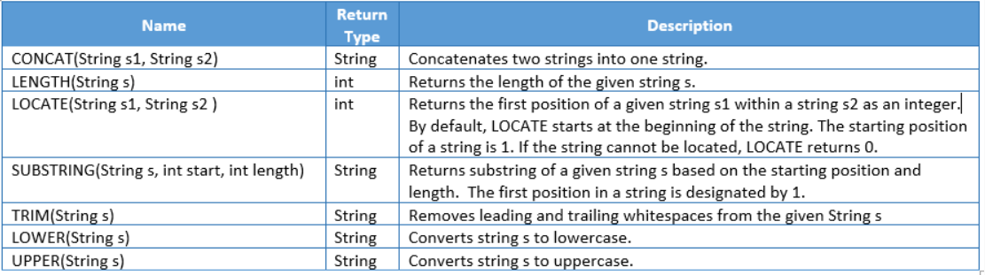
The GROUP BY clause is used for defining query results into groups. For example, the following query groups the customers by their city and returns the number of customers per city:
- SELECT c.city, COUNT(c) FROM Customer c GROUP BY c.city
The HAVING clause is used with the GROUP BY clause to filter the groups. For example, the following query groups customers by their city and returns the number of customers in city Seatle or Vancouver:
- SELECT c.city, COUNT(c) FROM Customer c GROUP BY c.city HAVING c.city IN ('Seatle','Vancouver')
The ORDER BY clause is used to sort the query results. To sort query results, give one or more attributes of entity class according to which results have to be sorted after ORDER BY clause. By default, results are sorted in ascending order. To sort the results in descending order DESC keyword is used. The following JPQL query selects all customers in the ascending order of their name:
- SELECT c FROM Customer c ORDER BY c.name ASC

Update Queries
For performing update operation, JPQL provides UPDATE statement. The following query updates the city of a customer whose customerId is 1002 to "Seatle":
- UPDATE Customer c SET c.city = 'Seatle' where c.customerId = 1002;
An UPDATE statement is executed using the executeUpdate() method as follows:
- Query query = entityManager.createQuery("UPDATE Customer c SET c.city = 'Seatle' where c.customerId = 1002");
- int updatedEntities = query.executeUpdate();
It returns the number of entities affected by the operation.

Delete Queries
For performing delete operation, JPQL provides DELETE statement. The following query deletes all the inactive accounts:
- DELETE FROM Account a WHERE a.status = 'INACTIVE'
A DELETE statement is executed using the executeUpdate() method as follows:
- Query query = entityManager.createQuery("DELETE FROM Account a WHERE a.status = 'INACTIVE'");
- int updatedEntities = query.executeUpdate();
It returns the number of entities affected by the operation.
Delete queries do not follow cascade rules even if an entity has association relationship with other entities and cascade remove is enabled i.e. only entities of the type mentioned in query and its sub-classes will be removed.
The query fetches employee names ending with "k" and slices it from 2nd index position. In JPQL String functions string indexing starts from 1 (instead of 0), so this option is correct.

- Page<T> findAll(Pageable pageable)
  - This method returns a Page containing entities and accepts a Pageable object as parameter.
  - Page interface contains information about the content of the page and some other information such as total number of pages, current page number and whether the current is first page or last page. Some important methods are as follows:
- Pageable interface contains information about pagination such as size and page number. It is implemented by PageRequest class. You can create its objects using the following methods of PageRequest class:
- Iterable<T> findAll(Sort sort)
  - This method returns all the entities in sorted order.
  - It accepts object of Sort class as parameter. This object contains information about the fields on which sorting is done and direction of sorting, i.e., ascending or descending.

To sort the transaction details using transaction date, you need to first create an object of Sort class using by() method with transactionDate as parameter value and then pass the Sort object to findAll() method as follows:
- // Sorted by 'transactionDate' attribute in ascending order
- Sort sort = Sort.by("transactionDate");
- Iterable<Transaction> transactions = transactionRepository.findAll(sort);
To sort the details in descending order of transaction date, you need to use the descending () method as follows:
- // ordered by 'transactionDate' attribute in descending order
- Sort sort = Sort.by("transactionDate").descending();
- Iterable<Transaction> transactions = transactionRepository.findAll(sort);
You can also sort by transaction date and then by transaction amount as follows:
- // sorted by 'transactionDate' attribute in descending order and 'transactionAmount' in ascending order
- Sort sort = Sort.by("transactionDate").descending().and(Sort.by("transactionAmount"));
- Iterable<Transaction> transactions = transactionRepository.findAll(sort);
If you want to find transaction details after a specific transaction date and sorted based on transaction date along with pagination, then you have to add query method to TransactionRepository as follows:
- public interface TransactionRepository extends PagingAndSortingRepository<Transaction, Integer>{
- public List<TransactionEntity> findByTransactionDateAfter(LocalDate transactionDate, Pageable pageable);
- }
If you want to fetch the details of transactions which are performed after 29-Jan-1996 and sorted based on transaction date with page size = 2, then, you need to create an object of Sort using by() method with transactionDate as parameter value. Then, you need to create Pageable object with page number = 0, page size = 2 and object of Sort class and pass this Pageable object to findByTransactionDateAfter() method along with transaction date as follows:
- LocalDate transactionDate = LocalDate.of(1996, 1, 29);
- Sort sort = Sort.by("transactionDate");
- Pageable pageable = PageRequest.of(0,2,sort);
- List<Transaction> transactionList = transactionRepository.findByTransactionDateAfter(transactionDate, pageable);

In this strategy, the value of the primary key is generated using the identity column of the table. The identity column of a table is an integer column having a primary key or unique constraint with the AUTO_INCREMENT feature. For example, in following customer table customer_id is an identity column:
- CREATE TABLE customer (
- customer_id int AUTO_INCREMENT,
- email_id varchar(20),
- name varchar(10),
- date_of_birth date,
- constraint ps_customer_id_pk primary key (customer_id)
- );
In this strategy, if there are no rows in the table, the starting value of the identity column will be 1, and it will be incremented by 1 for each new row added. If the rows are already present in the table, then the maximum value from the identity column is taken and incremented by 1 to generate the next primary key value.
To use this strategy, the primary key attribute of the entity class is annotated with @GeneratedValue annotation with GenerationType.IDENTITY as the value of the strategy attribute along with @Id annotation. The following code snippet shows how @GeneratedValue annotation is used to generate values for customerId:
- @Entity
- public class Customer{
- @Id
- @GeneratedValue(strategy=GenerationType.IDENTITY)
- private Integer customerId;

- // rest of the code
- }
To use this table for generating primary key values for customerId @TableGenerator annotation is used as follows:
- @Entity
- public class Customer{
- @Id
- @TableGenerator(
- name="pkgen",
- table="id_gen",
- pkColumnName="gen_key",
- valueColumnName="gen_value",
- pkColumnValue="cust_id",
- allocationSize=1)
- @GeneratedValue(generator="pkgen",strategy=GenerationType.TABLE)
- private Integer customerId;
- //rest of the code
- }
When you persist a new Customer entity, JPA generates next primary key value from the value present in gen_value column by incrementing it by 1. For example, if the value in the gen_value column is 5 and you persist a new Customer entity object then customer details with customerId as 6 will be persisted in the customer table and the value in the gen_value column will be updated to 6.
The @TableGenerator annotation has the following attributes:
- name : It specifies the name of the generator. This name is used to access the generator inside the entity class.
- table : It specifies the name of the table which has to be used for generating primary key values. In our case the table is id_gen.
- pkColumnName : It is the name of the primary key column which contains generator names used for generating primary key value. In our case pkColumnName is gen_key.
- valueColumnName : It is the name of the column which contains the last primary key value generated. In our case valueColumnName is gen_value.
- pkColumnValue : In table, many generators are may be present. This attribute specifies which generator has to be used for generating primary key value among a set of generators in the table. In our case pkColumnValue is cust_id.
- allocationSize : It specifies the amount to increment by when allocating id numbers from the generator.

Directionality
Consider the following Customer and Address classes :
- class Customer{
- private Integer customerId;
- private String customerName;
- private Address customerAddress;
- //getter and setter methods
- }
- class Address{
- private Integer addressId;
- private String doorNumber;
- private String city;
- //getter and setter methods
- }
The Customer has a reference of Address class. So, you can get the address of a customer if you know customerId. But you cannot get details of a customer if you know addressId because the Address class does not have a reference of Customer class. Such type of relationships is called unidirectional relationship. In these relationships the class which has reference of other class is called as owner or source of the relationship and the class whose reference is present is called a target of the relationship. So here, the Customer is the owner and the Address is the target.
The Customer has a reference of Address class and vice versa. So, you can get the address of a customer if you know customerId and also customer details if you know addressId. Such types of relationships are called a bidirectional relationship (not covered as part of this course).
Cardinality
The cardinality of a relationship defines how many entities exist on each side of the same relationship instance. In our Customer and Address example, one customer can have many addresses, so the cardinality of the Customer side is one, and the Address side is many. On the basis of cardinality, we have the following types of relationships:
- One – to – One Relationship
- One – to – Many Relationship
- Many – to – One Relationship
The Customer is the owner of the relationship and is mapped with the Customer table and has a reference of Address as shown below:
- @Entity
- public class Customer {
- @Id
- @GeneratedValue(strategy=GenerationType.IDENTITY)
- private Integer customerId;
- private String emailId;
- private String name;
- private LocalDate dateOfBirth;
- @OneToOne(cascade = CascadeType.ALL)
- @JoinColumn(name = "address_id", unique = true)
- private Address address;
- //getter and setter
- }
In the above code the reference of Address in annotated with @OneToOne annotation which declares that there is a one-to-one relationship between Customer and Address entity classes. The @JoinColumn annotation is used to define the name of the foreign key column in the Customer table that links the customer to the address. Now let us understand these annotations in detail:
@OneToOne(cascade = CascadeType.ALL)
- This annotation specifies that the association relationship has one-to-one multiplicity.
- The cascade attribute specifies operations performed on the owner entity that must be transferred or cascaded to the target entity. It takes values of type CascadeType enumeration. The values of this enumeration are PERSIST, REFRESH, REMOVE, MERGE, DETACH, and ALL. The value ALL specifies that all operations performed on Customer will be cascaded to Address. By default, none of the operations will be cascaded.
@JoinColumn(name = "address_id", unique = true)
- This annotation is used to specify the foreign key column that joins the owner and target entity.
- The name attribute specifies the name of the foreign key column in the table mapped to the owner entity.
- The unique = true assures that unique values will be stored in the join column.
The Loan entity class is the owner's side of relationship and is mapped with Loan table. This has a reference of Customer entity class as shown below:
- @Entity
- public class Loan{
- @Id
- @GeneratedValue(strategy=GenerationType.IDENTITY)
- private Integer loanId;
- private Double amount;
- private LocalDate issueDate;
- private String status;
- @ManyToOne(cascade=CascadeType.ALL)
- @JoinColumn(name="cust_id")
- private Customer customer;

- //getter and setter methods
- }
In the above code the reference of Customer entity class in annotated with @ManyToOne annotation which declares that there is many-to-one relationship between Customer and Loan. The @JoinColumn annotation is used to define the name of the foreign key column in the Customer table that links the customer to the card. Now let us understand these annotations in detail:
@ManyToOne(cascade = CascadeType.ALL)
- This annotation indicates that the relationship has many-to-one cardinality.
- The cascade attribute tells which operation (such as insert, update, delete) performed on source entity can be transferred or cascaded to target entity. By default, none of the operations will be cascaded. It takes values of type CascadeType enumeration. The value ALL means all operations will be cascaded from source to target. Other values of this enumeration are PERSIST, REFRESH, REMOVE, MERGE, and DETACH.
@JoinColumn(name = "cust_id")
- This annotation is used to define the name of the foreign key column that joins the owner and target entity.
- The name attribute specifies the name of the foreign key column in the table mapped to the source entity.

- In one-to-one relationship, join column is present is table which is mapped to source entity class of relationship.
- In many-to-one relationship, join column is present is table which is mapped to source entity class of relationship.
- In one-to-many relationship, join column is present is table which is mapped to target entity class of relationship.

Challenges in using JDBC
You have already learned how to use JDBC for data access. But using JDBC is challenging because of following reasons:
- Connection Management: In JDBC you have to write code for managing connections. If connections are not managed properly then application performance gets impacted.
- Exception Handling: The JDBC code throws SQLException which is a checked exception. So, you have to write code to handle them even though database errors are mostly unrecoverable. Also, inappropriate handling of SQLException leads to many other problems.
- Code Duplication: In JDBC lot of repetitive code is written to perform operations such as obtaining database connection, creating a statement, converting data obtained as rows and columns into objects etc. Because of this lot of time is spent in writing data persistence rather business logic. This effects project costs, efforts, and timelines.
So, to make use of JDBC easier Spring provided one layer of abstraction, called Spring JDBC, on top of existing JDBC technology. Now let us explore more about Spring JDBC.

Spring JDBC
Spring provides support for JDBC through Spring JDBC. It is a layer of abstraction on JDBC which makes use of JDBC easier and helps to avoid common errors. It consists of following four packages:
- org.springframework.jdbc.core – It contains core JDBC classes JdbcTemplate, SimpleJdbcCall, NamedParameterJdbcTemplate, and SimpleJdbcInsert.
- org.springframework.jdbc.datasource – It contains utility classes to access database and different implementation classes of DataSource.
- org.springframework.jdbc.object – It contains classes to access database in an object-oriented manner. It allows executing queries and returning the results as a model object. It also maps the query results between the columns and properties of objects.
- org.springframework.jdbc.support – It contains support classes for core and object packages and provides facility for SQLException translation.
The JdbcTemplate is core class of Spring JDBC.

JdbcTemplate
JdbcTemplate is the main class of Spring JDBC. It makes use of JDBC easy in following ways:
- It takes care of opening and closing of connections, so you need not to write the code for managing them.
- It provides various overloaded methods for executing SQL queries and handling results as different types of objects.
- It catches JDBC exceptions and translates them to more generic and informative exception.
It provides several overloaded methods to execute SQL queries. Some methods of this class are as follows:
- update() - This method is used for executing INSERT, UPDATE and DELETE queries.
- query() - This method is used for executing SELECT queries which can return multiple rows.
- queryForObject() - This method is used for executing SELECT queries which returns a single row.

You have learned how to configure a JPA application and create entity classes. Now you will see how to perform CRUD operations using JPA.
- For performing CRUD operations JPA provides a CRUD API. These operations are provided by the JPA EntityManager interface. Using methods of this interface you can operate on entities, fetch them, change their states, persist new ones, or delete already loaded ones. It helps you to manage transactions and so on. Some important methods of this interface are as follows:
  - void persist(Object entity) - Make an instance managed and persistent.
  - find(Class entityClass, Object primaryKey) - It searches for an entity of the specified class by primary key. If found it returns the entity instance otherwise if the entity does not exist it returns null.
  - void remove(Object entity) - Remove the entity instance.
  - EntityTransaction getTransaction() - It returns an EntityTransaction which is used to begin and commit transaction.
- To get an instance of EntityManager JPA provides EntiyManagerFactory. The object of EntiyManagerFactory can be created using createEntityManagerFactory() method in the Persistence class by passing name of the persistence unit which is specified in persistence.xml file’s persistence-unit tag as follows:
- EntityManagerFactory emf = Persistence.createEntityManagerFactory("JPA_CRUD");
Now we can create an EntityManager from the factory that we have created as follows:
- EntityManager em = emf.createEntityManager();
In JPA insert, delete, and update operations must be executed within an available active transaction. Otherwise, it will fail with an exception. So, we need a transaction to perform these operations. To control transaction on resource-local entity managers JPA provides EntityTransaction interface. The instance of this transaction can be obtained by EntityManager as follows:
- EntityTransaction et = em.getTransaction();
Using EntityTransaction transaction can be started and committed as follows:
- et.begin();
- et.commit();

Persisting customer details
The customer details can persisted in database using following steps:
1. Create an instance of EntityManagerFactory using the createEntityManagerFactory() method of Persistence class as follows:
- EntityManagerFactory emf=Persistence.createEntityManagerFactory("JPA_CRUD");
2. Using EntityManagerFactory create an object of EntityManager as follows:
- EntityManager em = Persistence.createEntityManager();
3. Using EntityManager create an object of EntityTransaction and begin the transaction as follows:
- EntityTransaction et = em.getTransaction().begin();
4. Create an object of entity class, populate it with values and make it persistent object by calling persist() method as follows:
- CustomerEntity entity=new CustomerEntity();
- entity.setCustomerId(customer.getCustomerId());
- entity.setDateOfBirth(customer.getDateOfBirth());
- entity.setEmailId(customer.getEmailId());
- entity.setName(customer.getName());
- em.persist(entity)
5. Commit the transaction as follows:
- em.getTransaction().commit();
6. Close the EntityManager and EntityManagerFactory.
The following code inserts the customer details in CUSTOMER table:
- public Integer addCustomer(Customer customer) throws Exception {
- EntityManagerFactory emf=null;
- EntityManager em=null;
- Integer customerId=null;
- try {
- emf=Persistence.createEntityManagerFactory("JPA_CRUD");
- em=emf.createEntityManager();
- CustomerEntity entity=new CustomerEntity();
- entity.setCustomerId(customer.getCustomerId());
- entity.setDateOfBirth(customer.getDateOfBirth());
- entity.setEmailId(customer.getEmailId());
- entity.setName(customer.getName());
- em.getTransaction().begin();
- em.persist(entity);
- em.getTransaction().commit();
- customerId=entity.getCustomerId();
- } catch (Exception e) {
- Logger logger=LogManager.getLogger(this.getClass());
- logger.error(e.getMessage(),e);
- throw e;
- }finally{
- if(em!=null && em.isOpen()){
- em.close();
- }
- if(emf!=null && emf.isOpen()){
- emf.close();
- }
- }
- return customerId;
- }

The customer details can be fetched from database using following steps:
1. Create an instance of EntityManagerFactory using the createEntityManagerFactory() method of Persistence class as follows:
- EntityManagerFactory emf=Persistence.createEntityManagerFactory("JPA_CRUD");
2. Using EntityManagerFactory create an object of EntityManager as follows:
- EntityManager em = Persistence.createEntityManager();
3. Fetch the customer details using find() method as follows:
- CustomerEntity customerEntity = em.find(CustomerEntity.class, customerId);
4. Close the EntityManager and EntityManagerFactory.

Updating customer details
The customer email id can be updated in database using following steps:
1. Create an instance of EntityManagerFactory using the createEntityManagerFactory() method of Persistence class as follows:
- EntityManagerFactory emf=Persistence.createEntityManagerFactory("JPA_CRUD");
2. Using EntityManagerFactory create an object of EntityManager as follows:
- EntityManager em = Persistence.createEntityManager();
3. Fetch the details of the customer using find() method and update the details which needs to be changed as follows:
- CustomerEntity customerEntity = em.find(CustomerEntity.class, customerId);
- customerEntity.setEmailId(emailId);
4. Using EntityManager create an object of EntityTransaction, begin and commit the transaction as follows:
- em.getTransaction().begin();
- em.getTransaction().commit();

Deleting customer details
The customer can be deleted from database using following steps:
1. Create an instance of EntityManagerFactory using the createEntityManagerFactory() method of Persistence class as follows:
- EntityManagerFactory emf=Persistence.createEntityManagerFactory("JPA_CRUD");
2. Using EntityManagerFactory create an object of EntityManager as follows:
- EntityManager em = Persistence.createEntityManager();
3. Fetch the details of the customer using find() method which needs to be deleted as follows:
- CustomerEntity customerEntity = em.find(CustomerEntity.class, customerId);
4. Delete the customer details using remove() method as follows:
- em.remove(customerEntity);
5. Using EntityManager create an object of EntityTransaction, begin and commit the transaction as follows:
- em.getTransaction().begin();
- em.getTransaction().commit();

